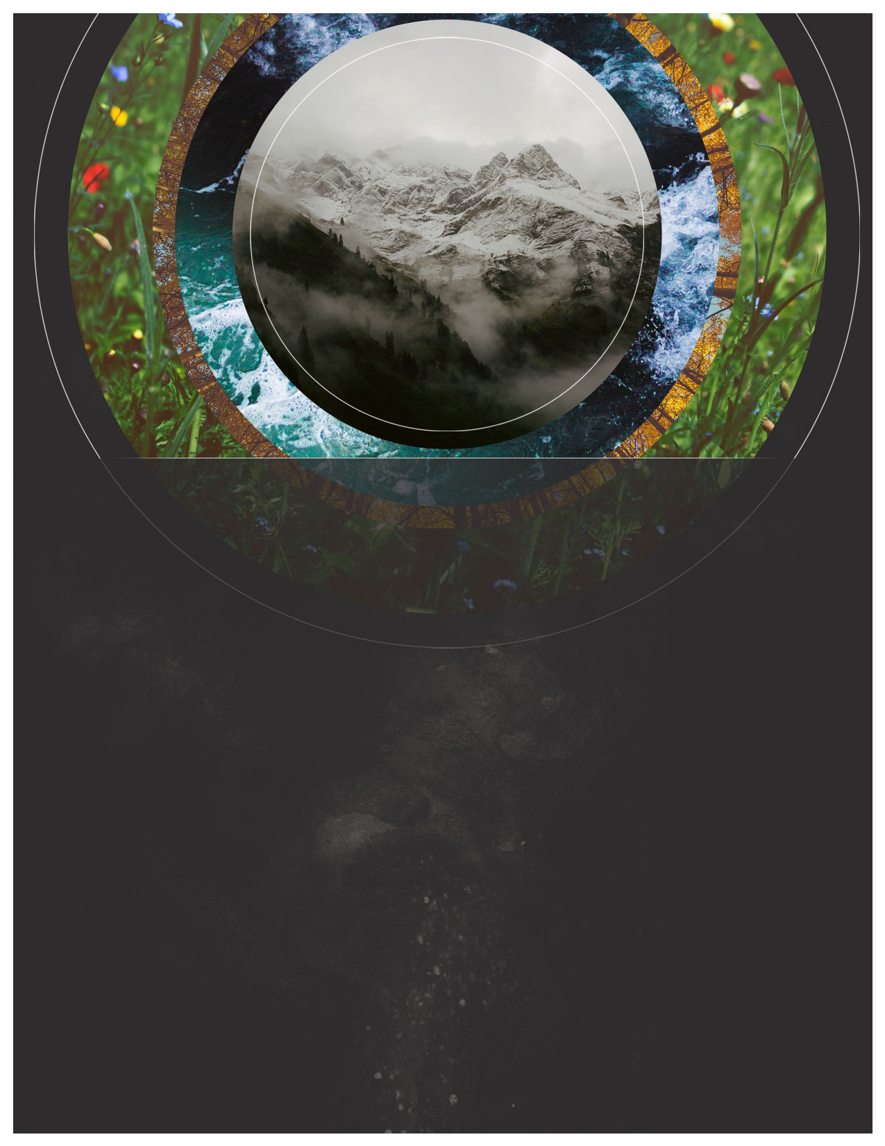

***St. Paul’s Lutheran Church***

*Welcome!*

**Keeping the Faith**

**Sharing the Faith**

**Living the Faith**

***Twelfth Sunday After Pentecost- August 23rd, 2020***

***Order of Service***

**Prelude/ Countdown**

**Welcome/ Announcements**

**Call to Worship Song: *More Like Jesus***

**Opening Prayer**

**Confession/ Absolution**

**Song/ Video: *Amazed***

**First Reading: *Isaiah 51:1-6***

**Second Reading:**

***Romans 11:33-12:8***

**Children’s Message**

**Gospel:  *Matthew 16:13-20***

**Sermon Song: *Who You Say I Am***

**Sermon**

**Apostle’s Creed**

**Prayers of the Church**

**Lord’s Prayer**

**Offering**

**Communion**

**Words of Institution**

**Distribution**

**Dismissal**

**Post-Communion Song/Hymn:**

***Take my life and let it be***

**Benediction**

**Closing Hymn:**

***Blest be the tie that binds***

**Closing**